**Chapter 3 - MEDIA LITERACY IN MODERN AGE**

**All Lectures Uploaded on YouTube:** [**https://tinyurl.com/fkm10-english**](https://tinyurl.com/fkm9-english)

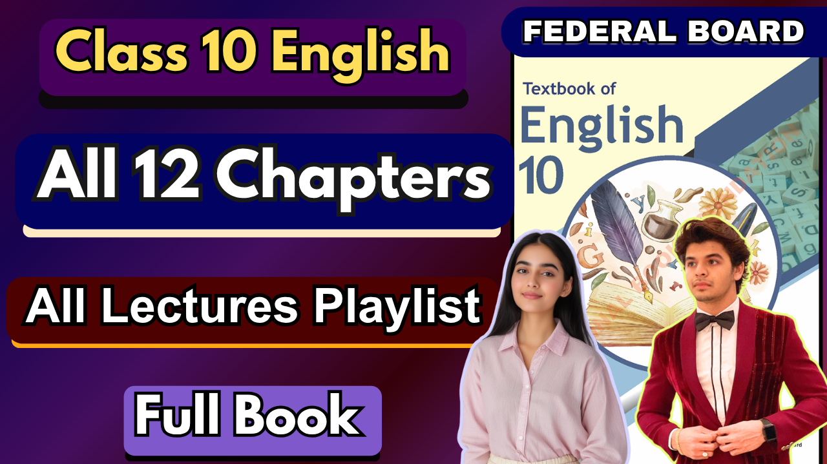

**Glossary:**

**Given below are the difficult words from the unit. Look at their meanings and use these words in your own sentences.**

| **Words** | **Meaning** |
| --- | --- |
| overstated | exaggerated or presented in a way that is too strong. |
| navigators | individuals who guide or find their way through something. |
| comprehensive | covering or including everything. |
| decoding | analyzing and interpreting information. |
| credibility | the quality of being trusted and believed in. |
| ascertaining | making sure of something; confirming. |
| pivotal | of crucial importance. |
| discern | perceive or recognize something. |
| extremist | someone who holds extreme political or religious views. |
| resilience | the capacity to recover quickly from difficulties. |

The following are the sentences for the above mentioned words:

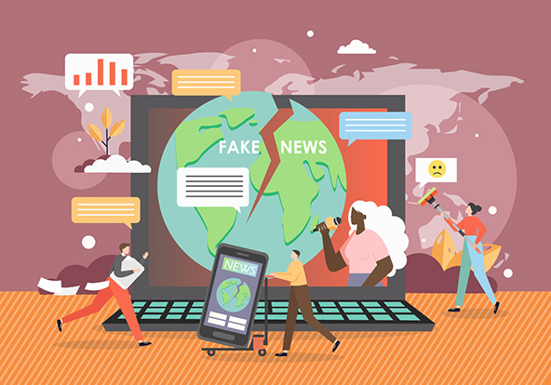

1. **Overstated** – The importance of the new policy was clearly overstated in the media.
2. **Navigators** – Ancient navigators relied on the stars to guide them across the seas.
3. **Comprehensive** – The teacher provided a comprehensive guide to prepare for the exam.
4. **Decoding** – Scientists are decoding the human genome to better understand genetic diseases.
5. **Credibility** – The journalist’s credibility was questioned after publishing inaccurate information.
6. **Ascertaining** – The detective focused on ascertaining the truth behind the suspect’s alibi.
7. **Pivotal** – The invention of electricity was a pivotal moment in human history.
8. **Discern** – From a distance, it was hard to discern whether the figure was waving or pointing.
9. **Extremist** – The government implemented stricter laws to counter extremist groups.
10. **Resilience** – Her resilience after the setback inspired everyone around her.

**Reading and Critical Thinking Skills**

**A. Read the unit and fill in the blanks**

**Ans.**

i. The significance of media literacy cannot be overstated; it transforms individuals from **passive consumers** into informed navigators of the complex web of modern information.

ii. Media literacy involves a comprehensive approach to assessing the **purpose, message, and impact** of information being viewed.

iii. Media literacy comprises several key components, including access, analysis, evaluation, creation, and **action**.

iv. Access in media literacy refers to the ability to obtain and use media in **various forms**.

v. Media literacy plays a pivotal role in promoting critical thinking and informed engagement with content that shapes **society**.

vi. Responsible content creation on mass media and social media platforms requires a clear understanding of the ethical implications of one's **actions**.

vii. Media literacy empowers individuals to seek out and engage with a wide range of **perspectives**, enhancing critical thinking and understanding global issues.

**B. Read the unit carefully and answer the following questions.**

**i. What is media literacy, and why is it considered a vital skill in the modern era?  
Ans.** Media literacy is the ability to access, analyze, evaluate, create, and act upon media content in a critical and responsible way. It is vital today because people are constantly exposed to a flood of information through television, social media, advertisements, and digital platforms. Without media literacy, individuals can easily be misled by biased reporting, fake news, or extremist propaganda.

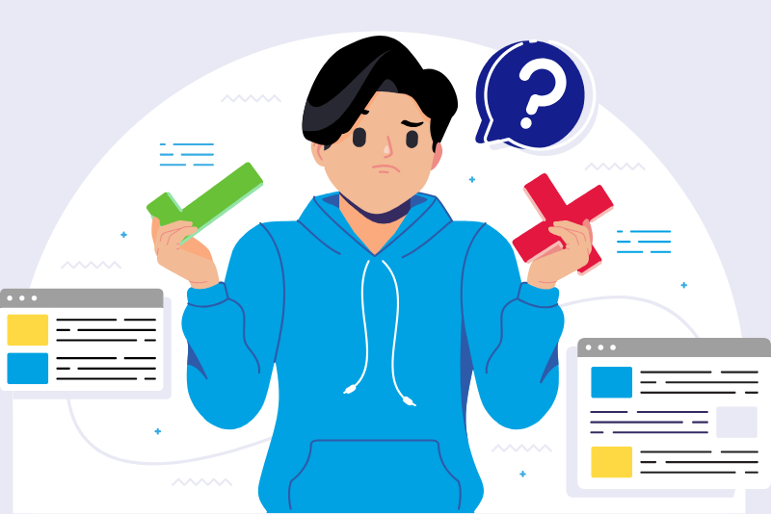

**ii. Explain the significance of each key component of media literacy (Access, Analysis, Evaluation, Creation, Action) in navigating the modern media landscape.  
Ans.**

* **Access** – The skill of obtaining and using different types of media effectively. It ensures individuals can reach authentic information rather than being restricted to unreliable sources.
* **Analysis** – The process of carefully studying the content, message, and motives of media. This helps in uncovering hidden agendas or persuasive techniques.
* **Evaluation** – Making informed judgments about the credibility, reliability, and bias of media messages. It helps separate fact from opinion.
* **Creation** – The ability to produce responsible and ethical media content. This develops one’s voice in society while ensuring respect for truth and values.
* **Action** – Using media in socially responsible ways, including promoting awareness, standing against misinformation, and encouraging civic engagement.

**iii. Provide examples of how media literacy can be applied to combat fake news and promote responsible content creation.  
Ans.**

* **Combating fake news**: By checking multiple sources, verifying facts, and recognizing clickbait or manipulated images, individuals can avoid spreading misinformation.
* **Promoting responsible content**: A content creator who understands ethics will avoid hate speech, sensationalism, or plagiarism and instead share accurate, respectful, and balanced information.

**iv. How does media literacy contribute to creating a well-informed and critically thinking individual capable of engaging with diverse perspectives?  
Ans.** Media literacy equips individuals with critical thinking tools to question, compare, and interpret different viewpoints. This allows them to recognize cultural biases, engage with global issues, and make balanced judgments instead of blindly following one-sided narratives.

**v. Discuss the role of media literacy in guarding against extremism.  
Ans.** Media literacy helps individuals identify extremist propaganda, misleading narratives, and hate-filled content. By analyzing and evaluating such media critically, people can resist radicalization and instead promote tolerance, peace, and coexistence.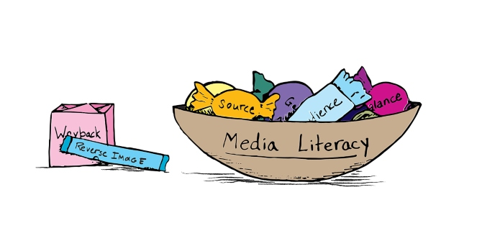

**vi. How can media literacy promote healthy media habits?  
Ans.** It encourages mindful use of media by teaching individuals to:

* Balance screen time and real-life interactions.
* Avoid addiction to social media and entertainment.
* Choose credible sources over sensational or harmful ones.
* Use media as a tool for learning and growth rather than manipulation.

**Vocabulary and Grammar**

**Transitional Devices**

Transitional devices are words or phrases that connect ideas, sentences, or paragraphs smoothly. They guide the reader by showing relationships between ideas. When writing about similarities (comparison) or differences (contrast), transitional devices make the text clear and logical.

### **Transitional Devices for Comparison**

These words show similarity or likeness between two or more ideas.

* **Similarly:** Indicates a similarity between two ideas or points.
* **Likewise:** Shows agreement or similarity in the context of comparison.
* **In the same way:** Points out a shared characteristic or method.
* **Compared to:** Highlights similarities or differences between two entities.
* **Just as:** Draws a parallel between two comparable situations.

### **Transitional Devices for Contrast**

These words show differences or highlight opposing ideas.

* **However:** Introduces a contrasting idea or point.
* **On the other hand:** Presents an opposing viewpoint or situation.
* **In contrast:** Emphasizes the differences between two ideas.
* **Nevertheless:** Signals a concession or acknowledgment of opposing information.
* **Conversely:** Indicates a contrasting relationship between two statements.

**Identify the transitional devices used in the passage. Also differentiate if the device is of comparison or contrast.**

**Ans.** Excessive screen time has become common in our lives, similarly *(comparison)*, to an ever-present companion. In contrast *(contrast)*, the physical toll is evident; inactive habits lead to health issues. Likewise *(comparison)*, mental health suffers, with increased screen exposure comes heightened stress. On the other hand *(contrast)*, moderation promotes well-being. Conversely *(contrast)*, neglecting this balance jeopardizes our physical and mental equilibrium. Striking a harmonious blend, however *(contrast)*, ensures a healthier and more balanced lifestyle for the long term.

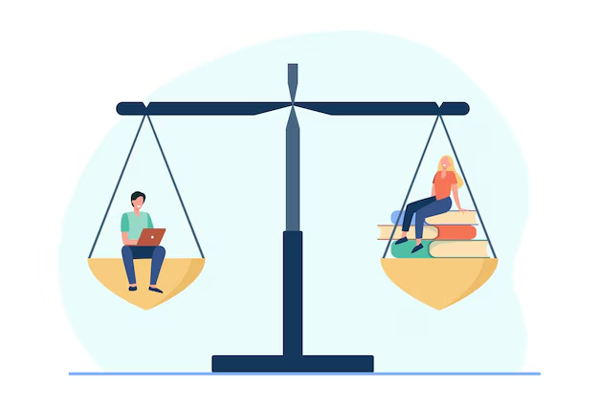

**Complete the sentences by choosing the appropriate transitional device.**

**Ans.**

i. The movie was entertaining; **however**, the book was more detailed.

ii. Ayan is tall; **in contrast**, his sister is quite short.

iii. Our school focuses more on science; **on the other hand**, the neighboring school focuses on the arts.

iv. Tom likes to study in the morning; **whereas** his roommate prefers late-night studying.

v. She enjoyed playing basketball; **while** her brother preferred soccer.

**Personal Pronouns**

Personal pronouns are words used in place of nouns to refer to specific people, animals, or things. They make sentences less repetitive and smoother by avoiding the need to repeat names or nouns.

Instead of: *Ali is my friend. Ali plays cricket. Ali studies in my class.*We say: *Ali is my friend.* ***He*** *plays cricket.* ***He*** *studies in my class.*

### **Categories of Personal Pronouns**

Personal pronouns are broadly divided into three categories based on the point of view:

#### **1. First Person Pronoun**

These refer to the person who is speaking (the speaker).

* **Singular**: I, me, my, mine
* **Plural**: we, us, our, ours

**Examples:**

* *I am going to the park.*
* *We enjoyed our trip to the museum.*

#### **2. Second Person Pronoun**

These refer to the person being spoken to (the listener).

* **Singular and Plural**: you, your, yours

**Examples:**

* *You are my best friend.*
* *Did you bring your notebook?*

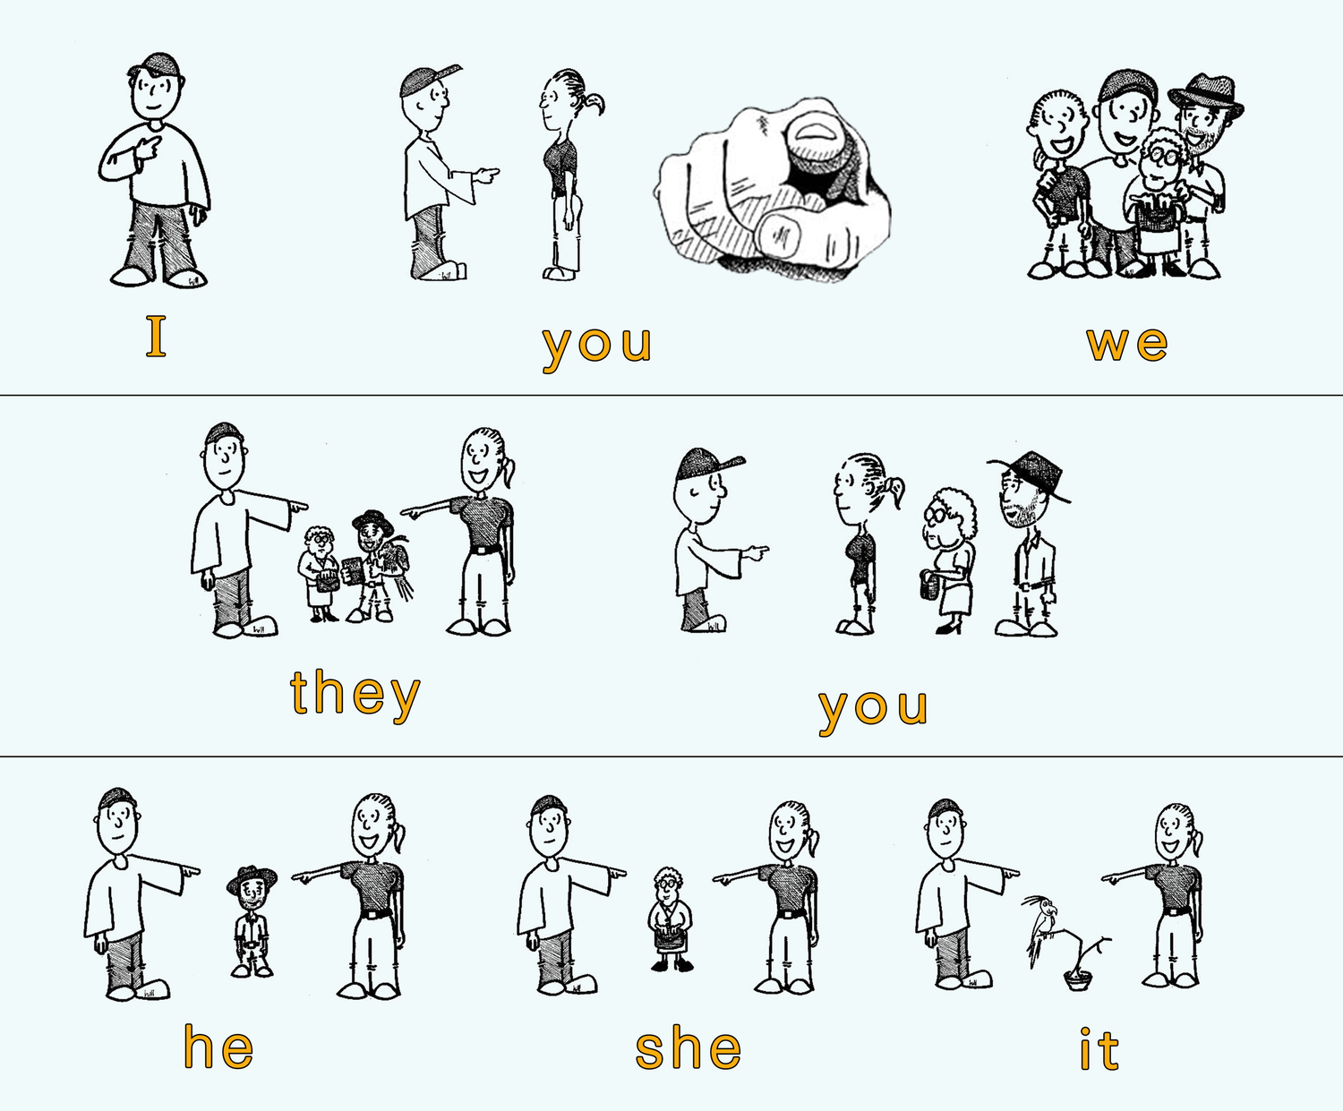

#### **3. Third Person Pronoun**

These refer to the person or thing being spoken about.

* **Singular**: he, him, his, she, her, hers, it, its
* **Plural**: they, them, their, theirs

**Examples:**

* *He is a doctor.*
* *She loves painting.*
* *They are playing football.*

**Read the following sentences and fill in the blanks with suitable personal pronouns.**

i. Do you know **he** is my brother.

ii. Areeba is a great cricketer. **She** has won many competitions.

iii. Would **you** like to go to the movies with Rubab?

iv. Van Gogh drew beautiful pictures. One of **his** famous works is 'The Starry Night'.

v. When the incident happened, Zaraq was present there. **He** was the only witness of the event.

vi. The dog gave birth to many puppies. Would **you** like to have one of **them**?

vii. Rizwan and Muneeba are siblings. **They** came to visit the museum.

viii. This is Nauman. **He** is the class monitor.

ix. The team won the match. **They** played surprisingly well.

x. My brother brought a new phone, but **he** doesn't like **it** much.

**Degree and Order of Adjectives**

### **1. Degrees of Comparison of Adjectives**

Adjectives describe qualities of nouns (e.g., tall boy, beautiful dress). When comparing these qualities, we use three **degrees of comparison**:

#### **a) Positive Degree**

* Used when no comparison is made; it just describes a noun.
* **Examples:**
  + Ali is **tall**.
  + She has a **beautiful** dress.

#### **b) Comparative Degree**

* Used when comparing two people, places, or things.
* Often formed by adding **-er** to the adjective, or using **more/less** before the adjective.
* **Examples:**
  + Ali is **taller** than Ahmed.
  + This book is **more interesting** than the other one.

**Rules:**

* For one-syllable adjectives → add **-er** (e.g., tall → taller).
* For adjectives ending in **y** → change *y* to *i* and add **-er** (e.g., happy → happier).
* For longer adjectives (2+ syllables) → use **more/less** (e.g., more beautiful, less expensive).

#### **c) Superlative Degree**

* Used when comparing more than two people, places, or things.
* Often formed by adding **-est** or using **most/least** before the adjective.
* **Examples:**
  + Ali is the **tallest** boy in the class.
  + This is the **most interesting** story I have ever read.

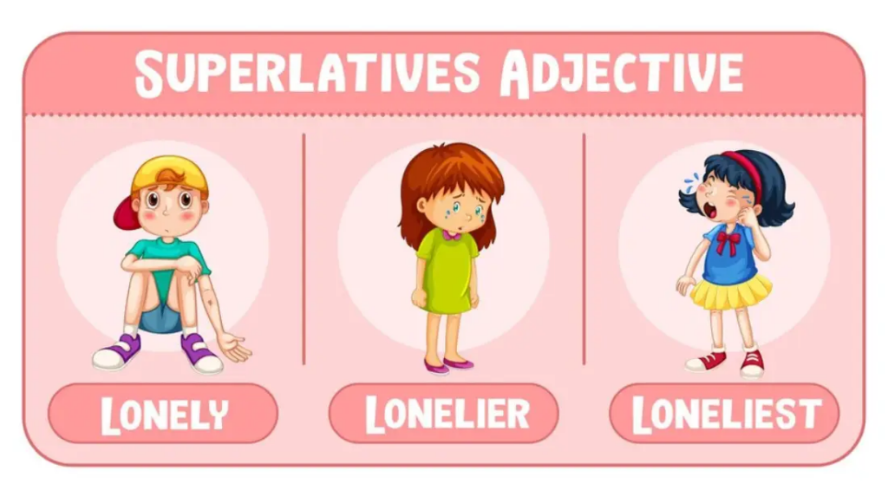

**Rules:**

* One-syllable adjectives → add **-est** (tall → tallest).
* Adjectives ending in **y** → change *y* to *i* and add **-est** (happy → happiest).
* Longer adjectives (2+ syllables) → use **most/least** (most beautiful, least important).

### **2. Order of Adjectives**

When more than one adjective is used before a noun, they must follow a natural **order**. The general sequence is:

1. **Opinion** → (beautiful, delicious, lovely)
2. **Size** → (small, big, tall)
3. **Age** → (young, old, new)
4. **Shape** → (round, square, long)
5. **Color** → (red, black, golden)
6. **Origin** → (Pakistani, Italian, Sindhi)
7. **Material** → (wooden, leather, gold, cotton)
8. **Purpose/Qualifier** → (sleeping [as in sleeping bag], wedding [as in wedding dress])
9. **Noun**

**Examples:**

* She wore a **beautiful small old round red Chinese wooden table clock**.
* We had a **delicious big homemade Italian pizza**.
* Ali bought a **new leather school bag**.

**Read these sentences and rewrite these with correct order of adjectives:**

i. Ali saw a **small black cat**.

ii. I bought a **new leather bag**.

iii. We had a **delicious homemade Italian dinner**.

iv. Shafaq wore a **beautiful red Sindhi dress**.

v. It was an **interesting old book**.

vi. He lives in a **big modern Spanish villa**.

vii. The students solved a **difficult complex math problem**.

viii. We visited an **ancient historic castle**.

ix. She received a **lovely gold necklace**.

**Things to Remember while using Degrees of Adjectives:** 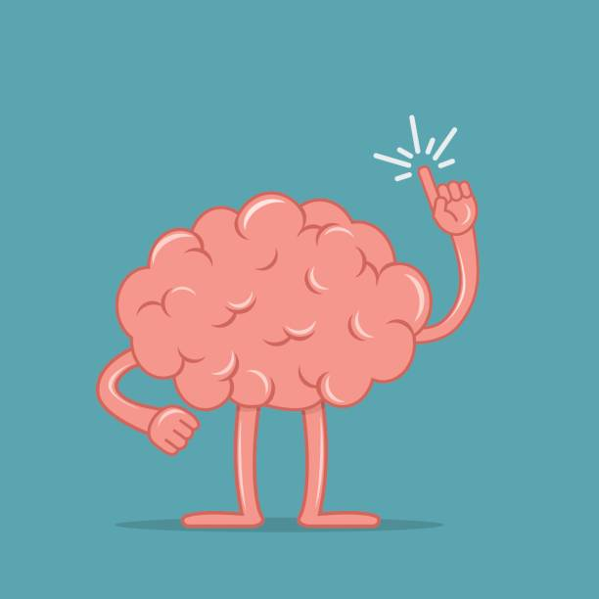

### **1. Positive Degree**

* Used to describe a quality without comparison.
* Example: *This road is* ***long****.*
* **Tip:** Do not use *than* or *the* with positive degree.

### **2. Comparative Degree**

* Used to compare **two people, places, or things**.
* Example: *This road is* ***longer*** *than that one.*
* **Tips:**
  + Always use **than** after the comparative form.
  + For one-syllable adjectives, add **-er** (e.g., tall → taller).
  + For adjectives ending in *y*, change *y* to *i* and add **-er** (e.g., happy → happier).
  + For adjectives of two or more syllables, use **more/less** (e.g., more useful, less expensive).

### **3. Superlative Degree**

* Used to compare **more than two people, places, or things**.
* Example: *This is the* ***longest*** *road in the city.*
* **Tips:**
  + Always use **the** before the superlative form.
  + For one-syllable adjectives, add **-est** (e.g., tall → tallest).
  + For adjectives ending in *y*, change *y* to *i* and add **-est** (e.g., happy → happiest).
  + For longer adjectives, use **most/least** (e.g., most beautiful, least important).

### **4. Irregular Adjectives**

Some adjectives have irregular comparative and superlative forms.

* good → better → best
* bad → worse → worst
* little → less → least
* many/much → more → most

### **5. Avoid Double Comparisons or Superlatives**

* Incorrect: *more better*, *most easiest*
* Correct: *better*, *easiest*

### **6. Consistency in Comparison**

* Compare similar things only.
* Incorrect: *The taste of this apple is better than an orange.*
* Correct: *The taste of this apple is better than that of an orange.*

**Adjective Phrase**

An **adjective phrase** is a group of words that works together to describe or qualify a noun or pronoun. It usually consists of an adjective as the headword, sometimes along with modifiers (adverbs, prepositions, or other words).

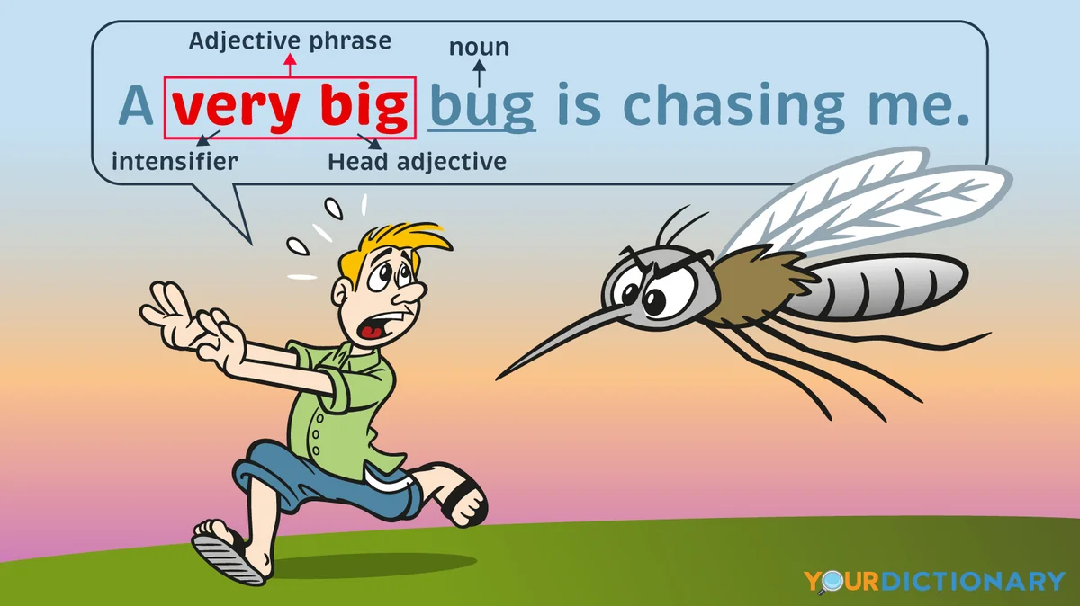

### **Examples of Adjective Phrases**

1. The house **with the red roof** belongs to my uncle.  
    *(“with the red roof” describes the house)*
2. She wore a dress **made of silk**.  
    *(“made of silk” describes the dress)*
3. The boy **full of energy** won the race.  
    *(“full of energy” describes the boy)*
4. We visited a city **famous for its historic buildings**.  
    *(“famous for its historic buildings” describes the city)*

### **Uses of Adjective Phrases**

1. **To describe nouns clearly**
   * *He bought a car* ***with tinted windows.*** → The phrase tells us more about the car.
2. **To give extra details**
   * *The students* ***eager to learn*** *paid close attention.* → Adds detail about “students.”
3. **To replace single adjectives with more descriptive information**
   * *The girl* ***with blue eyes*** *smiled at me.* → More vivid than just saying “the blue-eyed girl.”
4. **To make writing richer and more expressive**
   * *They live in a house* ***at the end of the street.*** → Adds color and detail to the noun “house.”

**Identify the adjective phrases in the following sentences:  
Ans.**

i. The house **on top of the hill** has a stunning view of the city.

ii. In the bustling city center, we found a charming little café **(none – adjectives are single words here)**.

iii. She wore a dress **with sparkles and sequins** for the special occasion.

iv. The detective examined the mysterious case **with a magnifying glass**.

v. A group **of energetic kids** played in the spacious, sunlit park.

vi. The old, creaky door **in the haunted mansion** gave everyone a fright.

vii. The scientist presented an experiment **with groundbreaking results**.

viii. The chef prepared a delicious meal **with fresh, locally sourced ingredients**.

ix. The dog **with the wagging tail** eagerly greeted its owner at the door.

x. The student **with the brilliant idea** received praise from the teacher.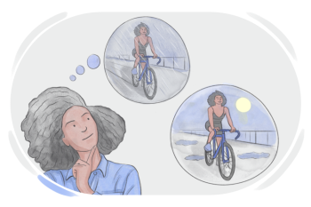

**Future Indefinite Tense**

The **Future Indefinite Tense** is used to describe an action that will happen in the future. It expresses decisions, promises, predictions, intentions, or plans.

### **Structure**

**Affirmative Sentence**:

* Subject + will/shall + base form of verb + object
* *Examples:*
  + I **will go** to school tomorrow.
  + We **shall meet** our teacher in the evening.

**Negative Sentence**:

* Subject + will/shall + not + base form of verb + object
* *Examples:*
  + She **will not attend** the meeting.
  + We **shall not forget** this day.

**Interrogative Sentence**:

* Will/Shall + subject + base form of verb + object + ?
* *Examples:*
  + **Will** you **visit** your grandparents this weekend?
  + **Shall** we **go** for a walk?

### **Examples in Sentences**

1. He **will call** you tonight.
2. They **will play** cricket on Sunday.
3. I **shall help** you with your homework.
4. The train **will leave** at 8 o’clock.
5. She **will not agree** to your plan.
6. **Will** Ali **participate** in the debate competition?

**Read the following passage and identify the sentences that use the future indefinite tense. Consider how the tense is employed to convey actions happening in the future.  
Ans.**

As the sun sets, Sarah looks forward to her upcoming trip. She has packed her bags and **will travel** to the serene mountains. The journey **won't take** long, and she **will explore** the picturesque landscapes. She **shall stay** in a cozy cabin and **will hike** to the mountaintop at sunrise. Sarah knows that this adventure **will create** lasting memories, and she **won't forget** the breathtaking views.

**Write a short paragraph (60-70 words) about what you will do on the coming weekend. Remember to use future indefinite tense.  
Ans.**

This coming weekend, I **will spend** time with my family and friends. On Saturday, I **will visit** my grandparents and **will help** them with household chores. In the evening, I **will go** to the park and **will play** cricket with my friends. On Sunday, I **will complete** my homework and **will watch** a movie. I am sure the weekend **will bring** me joy and relaxation.

